Adobe Illustrator  Worksheet #1 Illustrator provides many tools for creating and manipulating your artwork. In this worksheet you must match the correct selection from the gallery below with the corresponding definition. |  |  | 2020
 |  | sELECTION TOOL GALLERY
 | A. 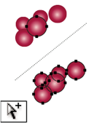B.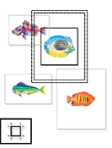C.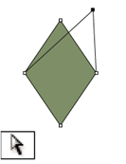D.E.F.

- The Selection tool (V) selects entire objects. ________
- The Group Selection tool selects objects and groups within groups. _______
- The Lasso tool (Q) selects points or path segments within objects.
________
- The Direct Selection tool (A) selects points or path segments within objects. _______
- The Magic Wand tool (Y) selects objects with similar attributes.
_________
- The Artboard tool creates separate artboards for printing or export. _______

