Adobe Illustrator  Worksheet #2 Illustrator provides many tools for creating and manipulating your artwork. In this worksheet you must match the correct selection from the gallery below with the corresponding definition. |  |  | 2020
 |  | Drawing TOOL GALLERY
 | A.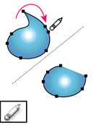B.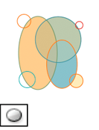 C.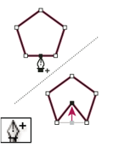 D.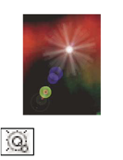 E.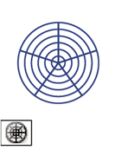F.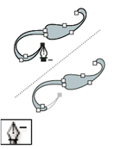G.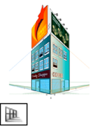H.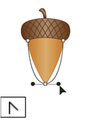I.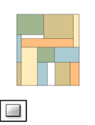J.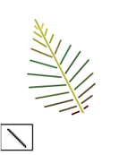K.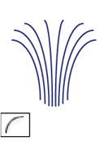L.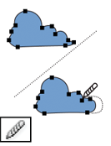M. N.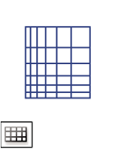 O.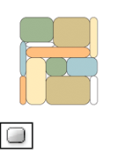 P.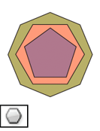Q.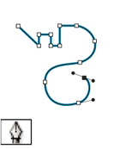R.S.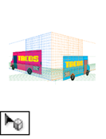T.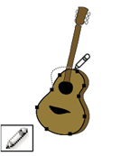
Worksheet 2
Continued…

Definitions

1.The Perspective Selection tool allows you to bring objects, text, and symbols in perspective, move objects in perspective, move objects in perpendicular to its current direction. ______
2. The Path Eraser tool erases paths and anchor points from the object. _____
3. The Pencil tool (N) draws and edits freehand lines. _____
4. The Star tool draws stars. _____
5. The Ellipse tool (L) draws circles and ovals. _____
6. The Rectangle tool (M) draws squares and rectangles. _____
7. The Rectangular Grid tool draws rectangular grids. _____
8. The Arc tool draws individual concave or convex curve segments. _____
9. The Convert Anchor Point tool (Shift+C) changes smooth points to corner points and vice versa. _____
10. The Add Anchor Point tool (+) adds anchor points to paths.
______
11. The Pen tool (P) draws straight and curved lines to create objects. ______
12. The Delete Anchor Point tool (-) deletes anchor points from paths. ______
13. The Line Segment tool (\) draws individual straight-line segments. ______
14. The Spiral tool draws clockwise and counterclockwise spirals.
_____
15. The Polar Grid tool draws circular chart grids. ______
16. The Rounded Rectangle tool draws squares and rectangles with rounded corners. ______
17. The Polygon tool draws regular, multi-sided shapes. ____
18. The Flare tool creates lens-flare or solar-flare-like effects. _____
19. The Smooth tool smooths Bezier paths. _____
20. The Perspective Grid allows creating and rendering artwork in perspective. _______

